# **Format for uploading details in GitHub and Slack in word file format**

**Student Name: Shrinivasa**

**Class and Sec: VI B**

**USN: 4AL17CS092**

|  |  |  |  |  |
| --- | --- | --- | --- | --- |
| **Online Test Details** | | | | |
| **Subject** | **Python Application Programming** | | | |
| **Semester** | **VI - B** | | **Duration** | **30 Minutes** |
| **85%** | | **17/20** | | |

**Encl: snapshot of the test result**

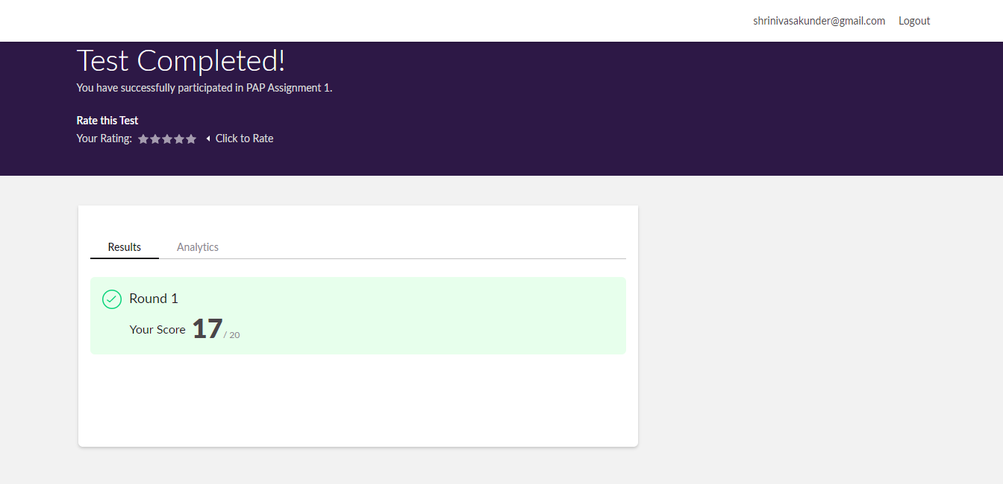

|  |  |  |  |
| --- | --- | --- | --- |
| **Certification Course Details** | | | |
| **Course** | **Blockchain Essentials** | | |
| **Certificate Provider** | **Cognitiveclass.ai** | **Duration** | **6 hours** |

**Encl: snapshots of the daily class activities (at least two snap shots)**

**Progress on 03-06-2020**

**Status: Completed**

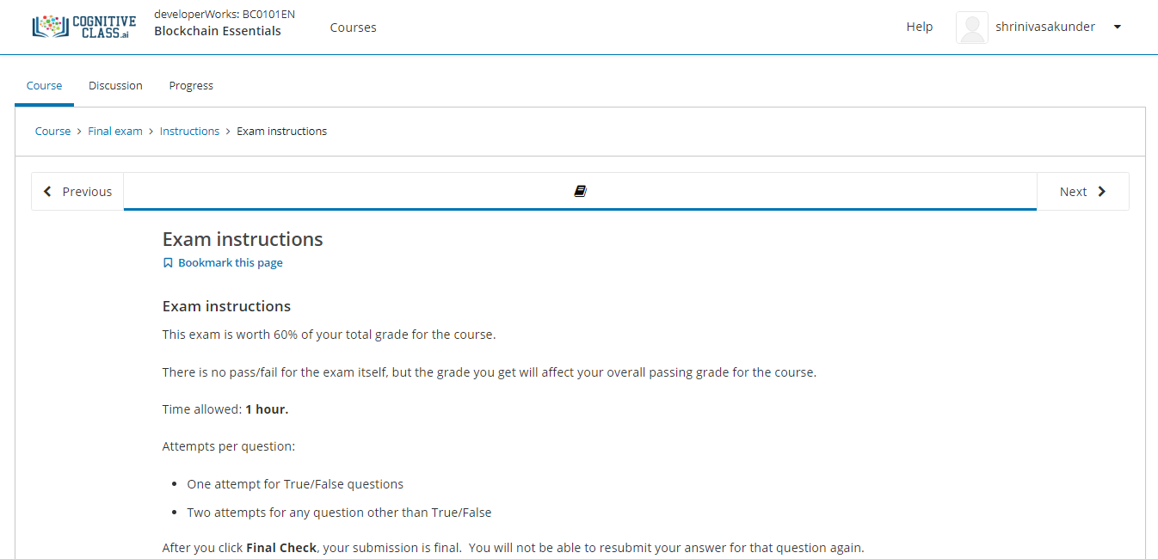

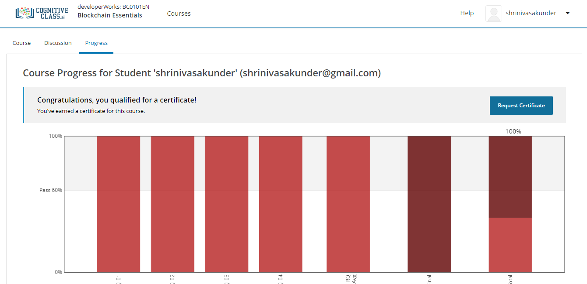

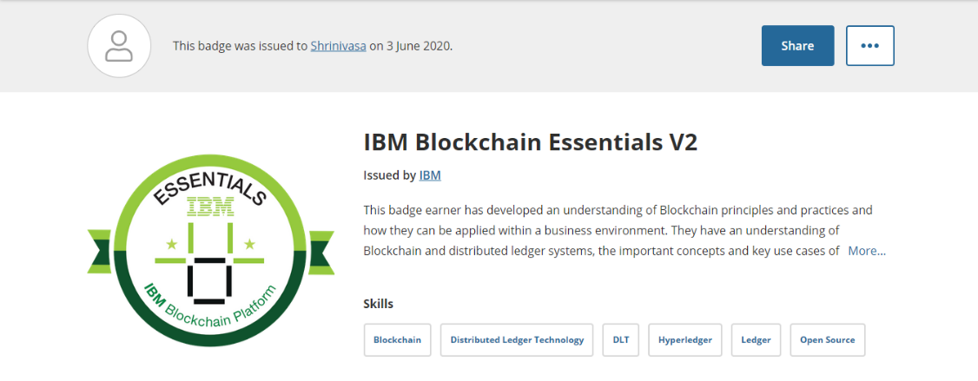

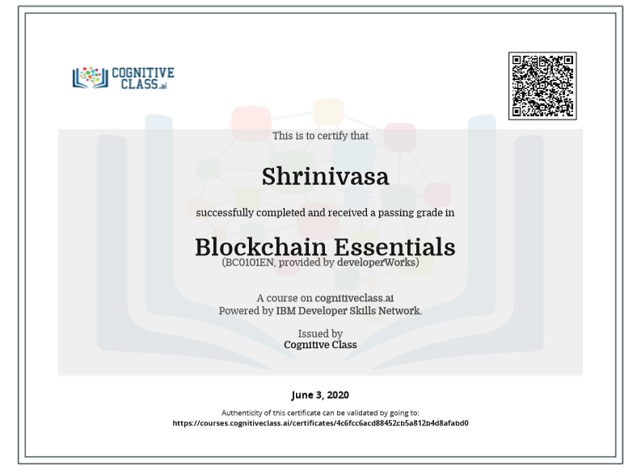

|  |  |
| --- | --- |
| **Coding Challenges** | |
| **Problem Statement: Pro1(python), Pro2(python), Pro3(python), Pro4(python), Pro5(python), Pro6(python), Pro7(python), Pro8(python), Pro9(java).** | |
| **Status: Completed** | |
| **Uploaded the report both in GitHub & Slack** | **Yes** |

**Encl: snapshots of your response to challenge.**

